Unit 9: Introduction to Visual Basic Events

Project 1:
Create a form like the one shown below.

Pressing the command buttons should:

- Change the background colour of the form to what is shown on the corresponding button
- Change the text colour of the text in the centre label as indicated on the foreground buttons.

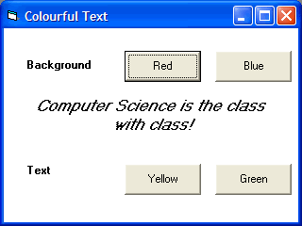

Save your project as vbpU9_ColorfulText_YourName

Project 2:
Create a form that contains four square buttons arranged in a rectangular pattern. Each button has the caption “Push Me.” When you click on a button, the button disappears and the other three buttons become visible. The four buttons should be positioned as shown.

Save the project as vbpU9_PushMe_YourName

Project 3:
Create a form that contains two text boxes with one large label between them. The label will not have a caption. When the focus is on the first text box, the label should read, “Enter your full name.” When the focus is on the second text box, the label should read, “Enter your phone number, including the area code.”

Save the project as vbpU9_NameNumber_YourName

Project 4:
Create a Hello World Program that will say Hello World in English, Spanish and French. A button should make it switch from each language. The button should also change the font and font size to a different type for each language.

Save the project as vbpU9_HelloWorld_YourName

Remember to provide remark statements (code comments). As an example:

lbl1.Caption = “Hi” ‘This green part is a code comment and is used to tell you that this code’s purpose is to display “Hi” in the Label named lbl1

Comments MUST BE PROVIDED from now on in all the remaining projects.

