Designing the Lucky Seven Game
In this lesson, you will start building the Lucky Seven game by creating a new project and then using controls in the toolbox to build the user interface.
- Open up Microsoft Visual Studio Express.
- Create a new program. Remember to name it correctly. Include your name in the title. Also, make sure you have saved it where you can find it again.
- Click the Form1 window to select it. Enlarge the form by dragging on the handles to make room for the objects in the program. As you resize the form, scroll bars will appear as shown.
- Click the CommandButton control in the toolbox. Move the mouse pointer over the form. The mouse pointer changes to crosshairs when it rests on the form. The crosshairs are designed to help you draw the rectangular shape of a command button. Hold down the left mouse button and drag. The command button object takes shape and snaps to the grid formed by the intersection of dots on the form. Create your first command button close to the upper left corner of the form as shown. By default, the name of the command button is Command1.
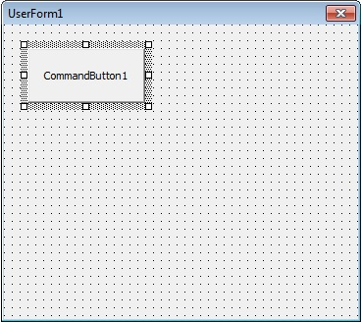
- Add a second command button below the first button on the form. Make the second button the same size as the first. You may move or resize the button after you place it by dragging on the handles.
- Click the Label control in the toolbox, and then place the mouse pointer over the form. Drag to create a small, rectangular box like the one shown below.
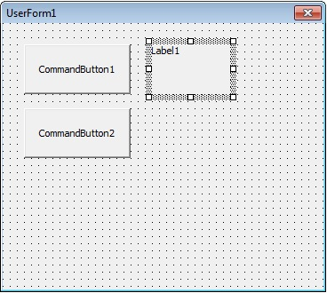
- By default, the label you created will be called Label1, the first label in the program. Create two more labels beside the first one, as shown. Make all three labels the same size.
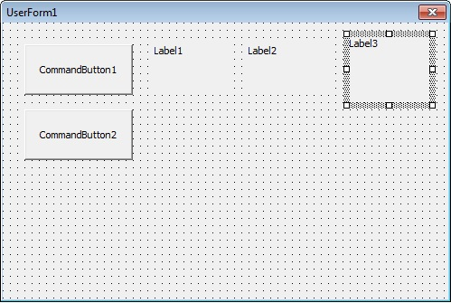
- Create a larger Label4 directly below the two command buttons, as shown.
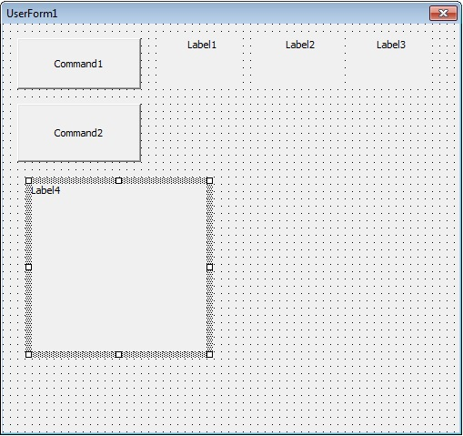
- Next, you will add an image box to the form to display the jackpot the user wins when a lucky seven is drawn.
- Select the Image control in the toolbox. Create a large rectangular box directly beneath the Label1, 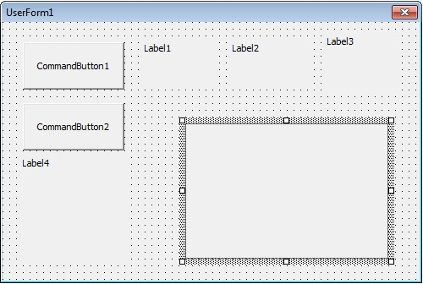Label2 and Label3 controls, as shown.

- Now we are ready to set the properties for these controls. Open the Properties window, if it is not already open.
- Select the first command button, called Command1. Once selected, it will be surrounded by selection handles.
- In the Properties window, double-click the Caption property in the left-hand column, as shown. Note: The Caption property is now called Text.
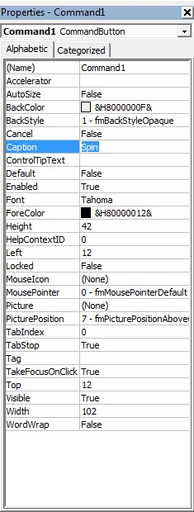
- Notice that the current name, Command1, is also selected in the right-hand column. You will rename the Command1 button. Type Spin and then press Enter. Notice that the caption property changes to Spin in the Properties window and on your form, as shown.

- Select Command2 and change the caption to End, as shown.

- Next, you will set the properties for Label1, Label2 and Label3. Click Label1 to select it. Hold down the Shift key and click Label2 and Label3. Selection handles will appear aound each of the three labels. Release the Shift key.
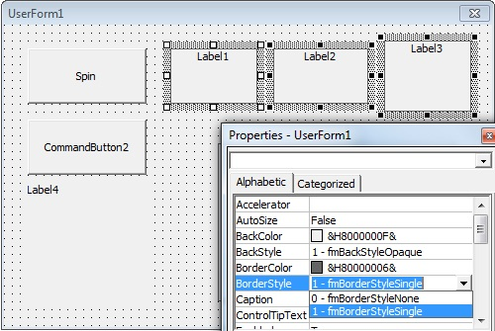
- In the Properties window, double-click the TextAlign (or Alignment for other versions of VB) property. A drop-down list box arrow appears in the right-hand column. Click the drop-down arrow to display a list of alignment options, as shown.

- Click the 2-Center option from this list.
- In the Properties window, double-click the BorderStyle property. Click the drop-down list arrow and select 1-Fixed Single, as shown.

- Double-click the Font property in the Property window. The Font dialog box appears, as shown.
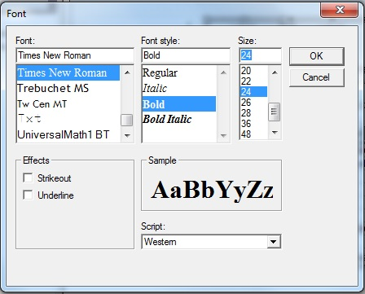
- Change the font to Times New Roman, the font style to Bold and the point size to 24, then click OK.
- Click the form to remove the selection handles from the three labels.
- Select Label1. Double-click the Caption property in the Property window. Press the Delete or Backspace key on the keyboard to delete the caption. Delete the captions for Label2 and Label3, as shown.
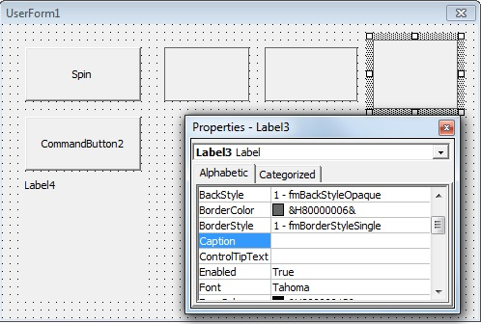
- Now you will change the Caption, Font and Fore Color properties on the last label, Label4. Click Label4 to select it.
- Double-click the Caption property and type Lucky Seven in the right-hand column.
- Double-click the Font property and use the Font dialog box to change the font to Arial, the style to Bold and the point size to 20. Click OK.
- Double-click the ForeColor property in the Property window. A list box appears with a System tab and a Palette tab. Select the Palette tab, then click the box containing the dark purple color. All the properties that were changed in steps 24 to 27 are shown below.
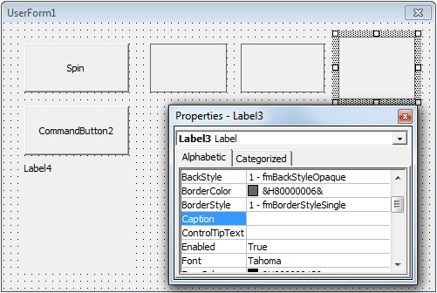
- Next, you will set the Stretch property to size the graphic that you will add to the form.
- Select the image box. Double-click the PictureSizeMode property, click the drop-down list arrow and select 1 - fmPictureSizeModeStretch, as shown.
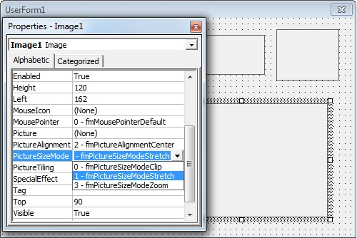
- Save the following image in My Pictures. Double-click the Picture property. The Load Picture dialog box appears, as shown.
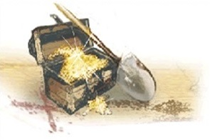
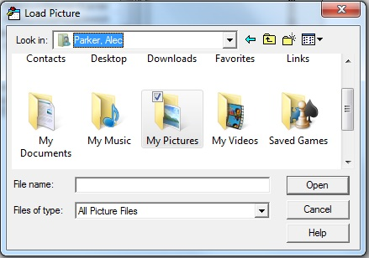
- Navigate to My Documents/My Pictures, as shown, and then select the image of the Treasure Chest and click Open. The image is loaded into the image box on the form, as shown.

- Now you will change the Visible property so that the treasure chest will be invisible when the program starts. Double-click the Visible property.
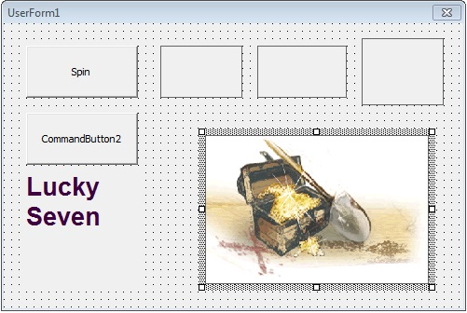
- Click the drop-down list arrow and select False.
- Now you are ready to write the code. Close the Properties window.
- Double-click the End command button on the form. This will open the Code window, as shown.
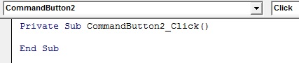
- Inside the code window, there are program statements that indicate the beginning and end of this particular Visual Basic subroutine, also known as an event procedure. A subroutine, or event procedure, is a block of code associated with a particular object in the interface. The body of the procedure always fits between these lines. The cursor is flashing on the line between:
Private Sub Command2_Click( )
End Sub
- Type End, then press the Down arrow key on the keyboard, as shown.
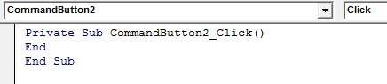
- Move the cursor to the beginning of the line with the End statement. Press the spacebar four times to move the End statement four spaces to the right, as shown.
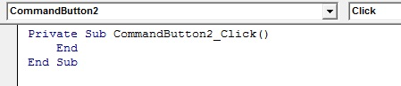
- Now you will write the code for the Command1 Spin button. Click the Object drop-down arrow and choose Command1 from the drop-down list, as shown. You can also double click on the Command1 button.
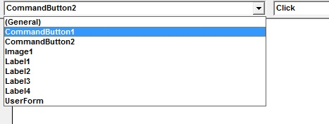
- Type the lines of code exactly as shown.
Image1.Visible = False 'hide coins
Label1.Caption = Int (Rnd * 10) 'pick numbers
Label2.Caption = Int (Rnd * 10)
Label3.Caption = Int (Rnd * 10)
'if any caption is 7 display treasure chest and beep
If (Label1.Caption = 7) Or (Label2.Caption = 7) _
Or (Label3.Caption = 7) Then
Image1.Visible = True
Beep
End If
- When you have finished, the code window should look exactly as shown.
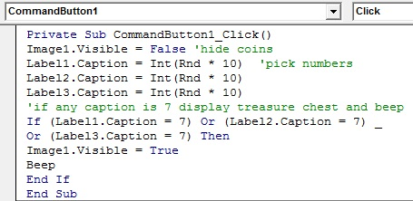
- Students find this first attempt at entering code to be the most difficult part of the lesson. It must be typed exactly as shown or it will not work. Pay close attention to your typing. I promise you that if you enter it exactly as shown, it will work!
- The last steps involve Saving our project and then running it. Click File->Save All
- In the New Folder box, type Practice and press Enter. A new folder named Practice is created as shown.
Note: For the rest of the course, you will save all your projects in the Practice folder.
- In the File name box, type MyLucky and press Enter. Your Lucky Seven form will be saved as MyLucky.docm
- The Save As dialog box appears again. The Practice folder should already be in the Save in box. In the File name box, type MyLucky and press Enter. This will save the project as MyLucky.docm.
- Congratulations! You are now ready to run your first Visual Basic program. Click Start on the menu bar. It likely won’t run so now it’s time to deal with syntax errors. A few things have changed between this version and VB 2012. The object Image is PictureBox now and the Caption property is Text. You will need to find and fix these in the code.
- The game interface that you created appears just as you designed it. Click the Spin button. Three random numbers will appear in the boxes. If number 7 shows in one of the boxes, the image will also appear and your computer will beep. If the number 7 does not show in one of the boxes, the image will not appear and you will not hear a beep. Continue to click the spin button to play the game. When you are finished playing, click the End button to end the game.
© New Brunswick Department of Education and Early Childhood Development. All Rights Reserved.

