Unit 16: Graphics and Animation

Create an application that uses an animation to simulate the sun rising and then setting and a rising and setting moon.

You can use any image of a sun that you find online. A sun should rise, travel across the sky and then set. As the sun sets and hits the water, it will become a half-circle in shape (which means that the bottom half will be hidden behind the water). At this point, it should stop moving and the blue sky should turn black. As the sky turns black the moon should start to rise and move across the screen.

The following images show one potential interface at the middle of the rising sun part and the sun as it sets below the water.

Extra value: The sun and moon should travel in a parabolic path use a parabolic function. 10% bonus.

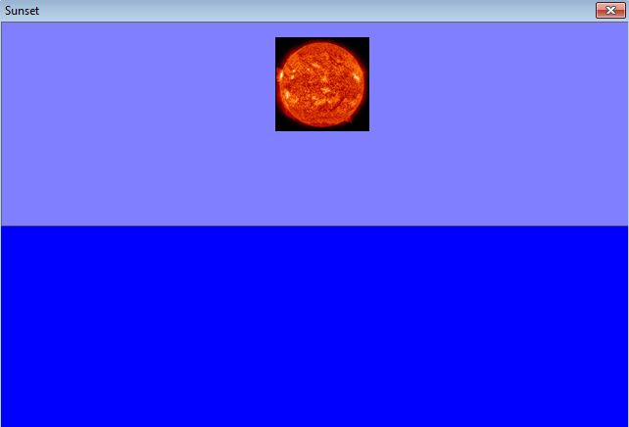
Save your project as Unit16_Sunset.
To submit your assignment, click the Dropbox link, select A13 and upload your files.

