Unit 14: Looping Structures and Program Flow

Create an application, called “Range Rover” that will calculate a sum of numbers within a range determined by the user.

The application will:

- Ask the user to enter two numbers, a starting number and an ending number.
- Using a loop, calculate the sum of all the numbers between the starting number and the ending number. The starting number and the ending number should also be included in the sum of all the numbers.

For example, if the user enters 1 and 5, as shown below, the application will calculate 1 + 2 + 3 + 4 + 5.

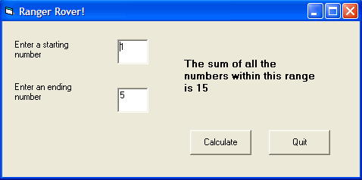

Save your project as vbpUnit14_RangeRover_YourName

Project 2 – Future Value Calculator

Create a program that allows a user to enter an interest rate, present value and number of years that the interest will compound. You should use a loop to determine the final value.

Use the following equation to determine the Final value:

Value = Value + Value x rate ‘Remember to change the rate to a decimal number

You should include a reset button. However, the reset Button shouldn’t appear until the calculate button is pressed and should disappear after it is clicked.

Your program should allow user to enter a negative interest rate as well for depreciation situation.

Below is a sample of what your program may look like.

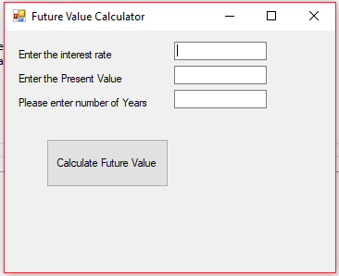

Remember to name it properly, include comments and submit a Word document of your code – separate from the zipped file.

