Unit 12: String Functions

Program 1
Write a program that asks the user to input:

- A sentence
- A word found in the sentence
- Another word to replace the first word that was selected

When the New Message button is clicked, the original sentence will be displayed with the user’s first word replaced by the second word.

For example, if the user types “Learning to write computer programs is easy.” into the first textbox, then easy and challenging into the second and third textboxes, the following message will be displayed, as shown in the interface below.

Note: String variables must be declared and used.

Note: Use a Label, not a Textbox, for the output.

Hint: Choose your strategy to solve this problem. Here are a couple of options:
- Use the Left, Right, Len and InStr functions to break the sentence apart and put it back together using the replacement word. These functions are demonstrated using examples in the content. Bonus 10% for the first 5 people that can solve with this method! (It is much more difficult and time consuming)
- Research the Replace function.

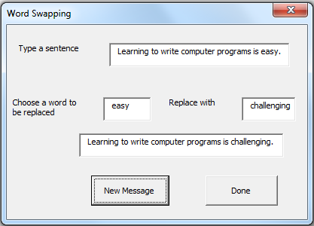

Save the project as vbpUnit12_WordSwapping_YourName.
Program 2
You’re task is to create a program that will create a username based on the first name, last name and ID number of the person entering the data. (Sounds familiar?)

Here are the rules for the username:
- Take the first 3 letters of the person’s first name
- Take the last 3 letters of the person’s first name
- Use the second to sixth numbers of their ID number (obviously the ID number must be 6 numbers or longer)
- Make it so that the when the ID number is entered it only shows a symbol not a letter (this step is to find the property setting. For example the box may display * for each number instead of the number)
- A label should tell the user what their username is when a button is clicked.
- Include a reset button and an End button.

Your form should look something like the following:
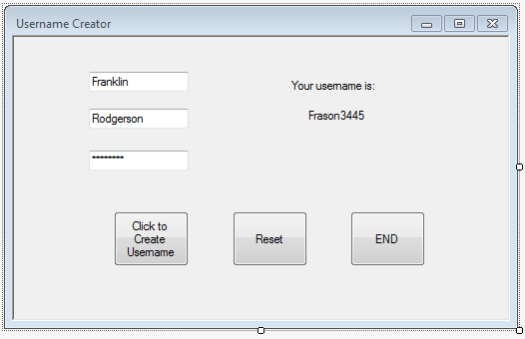

Note: String variables must be declared and used.

Note: Use a Label, not a Textbox, for the output.

Note: Don’t forget to comment and name your objects and project properly

Save the project as vbpUnit12_Username_YourName.

