Unit 8: Introduction to Visual Basic Objects

In this assignment, you will create interfaces for three projects. Start a new Visual Basic project for each interface. Note: You will have to experiment with some Visual Basic properties that have not been covered in the Unit 8 introductory lesson.

Project 1:
Create the interface shown in the image below:

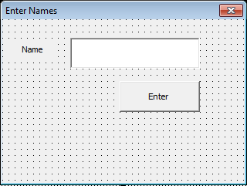

Save this project as vbpU8_EnterNames.

Project 2:
Create the interface shown in the image below:

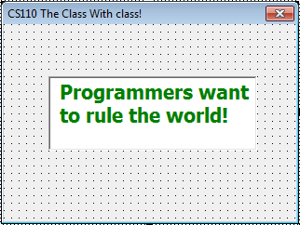

Note: To get the text to appear on two line, set the TextBox’ MultiLine property to True.

Save this project as vbpU8_TheClass.
Project 3:
Reproduce your student ID card on a Visual Basic form. You must include a picture. It does not have to be a picture of you if you do not have one available. If your school does not issue ID cards, then you should imagine what yours would look like if it did.

Save your project as vbpU8_IDCard.

Remember to
- properly name all six files
- not leave any form’s Text as UserForm1
- properly name all objects (see the page “Naming Objects (Continued)”)

THESE THINGS MUST BE DONE FROM NOW ON IN ALL THE REMAINING PROJECTS.

