Unit 17: Advanced Visual Basic Features

Option 1 : Density/Mass/Volume Solver

Create an application that will allow the user to choose whether they want to solve for Density, Mass or Volume if they have the other two variables. The main form should have a button that will allow the user to be shown another form that will allow them to input the values they have.

Your program should also include a form that will allow the user to convert values. For example: If the user has a value of mass in g or pounds it will show all variations at once. The same for density (g/cm^3) and volume. The conversions should have at least 3 possible choices. The form that the user is using should not close if a conversion is required.

Also, your program should have a safety feature built in to avoid the application crashing if the user does not enter a value in the input box. You should also include a check to make sure the input value is a numeric value.

Don’t ask questions if you haven’t done the hello Canada practice assignment.

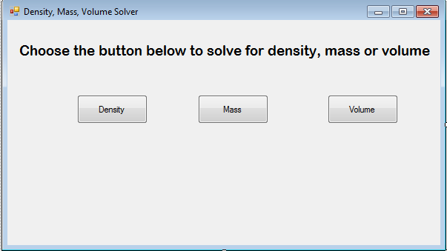

Save your project as Unit17_DVMSolver.

To submit your assignment, click the Dropbox link, select A14 and upload your files.

Option 2 : - Calculus Integral Solver

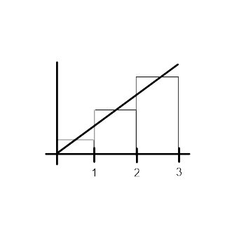
In calculus, the Integral function is used to determine the area under a curve. In Calculus, you will learn the mathematical process to solving the integral. The other method is to find the total of the areas of multiple rectangles that fill the area under the curve of the graph. For this program though, we will use a loop to determine the area of multiple rectangles.

For example if you look at the diagram above. If we took intervals of one and found the area of each rectangle, we would find the height using the equation at the midpoint between the intervals. Therefore, Area_1 would an interval of 1 and a height of y when x is equal to 0.5. Area_2 would be the same thing but when the height is y when x is equal to 1.5, etc.

Your task is to use this process to solve three different types of equations. Your main page should give you the choice of the equation type. Once you select an equation type, it will take you to a new page that will find the area for that specific type of equation.

Some examples of equations would be regular polynomial functions (use an equation of 4th order). Also, rational functions, radical functions or exponential functions could be used). No prerequisite required.

Option 3 – Physics Vector Solver

Create a program that gives you the choice of what you are solving. The main page should give you the choice of finding the resultant or finding a missing vector. You should also include an extra page that converts degrees into compass directions. Prerequisite is Physics 12.

Option 4 – Your own Solver Creation

Create a program that has some form of mathematical solver scenario. It should be a problem that has different variables you are trying to solve. If you wish to do something of your own creation, you must discuss it with me first in order to determine if it fits the requirements of the assignment.

